# CS 255 System Design Document Template

This template lays out all the different sections that you need to complete for Project Two. Each section has guidance to prompt your thinking. You will need to continually reference the interview transcript as you work to make sure that you are addressing your client’s needs. There is no required length for the final document. Instead the goal is to complete each section based on what your client’s needs are. Remove this note when you are finished, and replace all bracketed text with the relevant information.

## UML Diagrams

### UML Use Case Diagram6-3 UML Updated.pdf

### UML Activity Diagrams Schedule Driving Lesson:Schedule Driving Lesson.png

### Take Practice Test:Take Practice Test.png UML Sequence Diagram

### UML Class Diagram

## Technical RequirementsSequence diagram.png

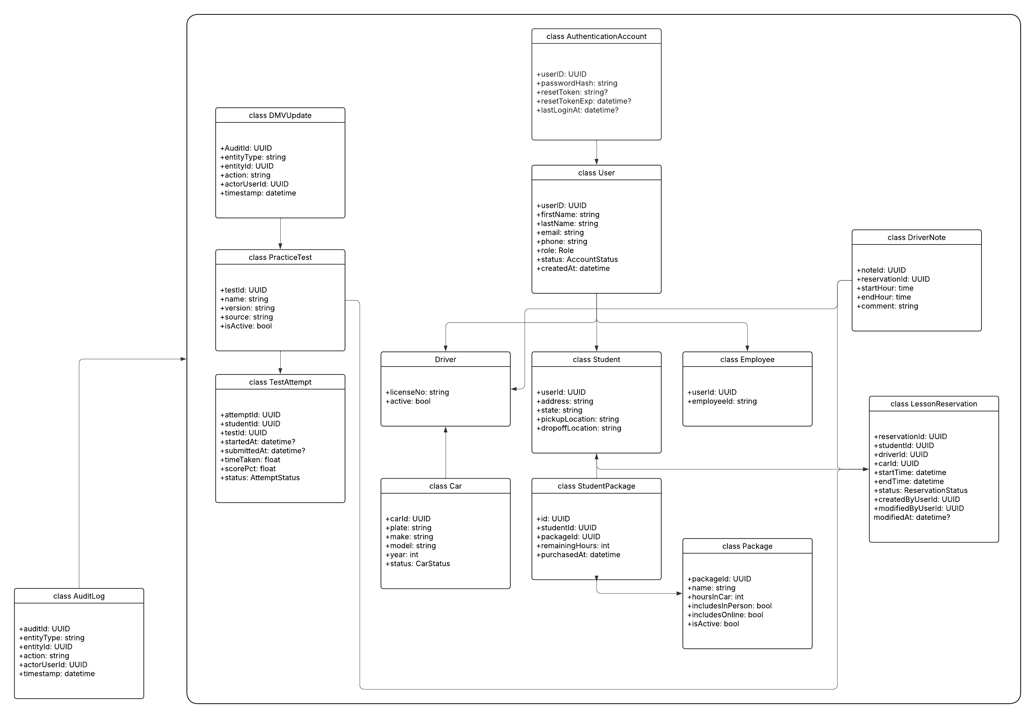For hardware, DriverPass wouldnt need servers due to being cloud hosted. The client side only requires computers or mobile devices with internet access. Employees such as secretaries or IT staff can use their regular machines to handle scheduling and account management.

For the stack, The system should use an easy straightforward system; a frontend built with HTML and JavaScript and a backend using a language like C# that is a bit stricter, or [Node.js](http://node.js/) due to the tight deadline. A relational database would also be fine to store data.

For Infrastructure, it’d be best to use a provider like AWS or Azure (or whatever the client requests) to host the system. This would be web hosting, database hosting, storage for reports, backups, and security. The cloud also helps with scalability.

For security, the IT officer must be able to reset passwords and block access when needed; otherwise for cloud / backend access, it will have to be given on an as needed basis, with rolling passwords and a consistently updated authorization list on the provider.

Regular updates should keep the software in sync with DMV rule changes and test updates. The system should also allow administrators to disable outdated packages.